# **Typographic Composition: Importance & Application**

## **Text's Subtle Language**

From magazine covers to billboards, you've seen graphic designers incorporate text in their designs your whole life. In fact, this is one area where graphic designers significantly differ from other visual artists, most of whom do not use text as heavily in their work. However, just adding words to a composition is rarely enough to create the desired effect. The visual presentation of the letters, their placement, and their characteristics often have a language of their own. This is why mastering the design element of typography is vital to your endeavors as a graphic designer.

## **What is Typography?**

**Typography** is the skillful application of letters, numbers, and other writing symbols to a graphic design composition. This involves a keen understanding of how different shapes of letters will add to or take away from your message. It also involves understanding how the text elements in a composition will interact with other elements and objects.

For example, you might find large, brightly-colored letters with rounded letters appropriate for a ''HAPPY BIRTHDAY'' banner. Should you use the same bubble letters for a health and safety warning? It might seem a bit inappropriate to warn people of a fatal disease outbreak with happy, childish letters.

## **Typeface**

What we may often call a font in a word processing program is also called a **typeface** in graphic design. Typefaces are the characteristics and styles of letters. Often, these key features are repeated throughout the entire set of uppercase letters, lowercase letters, numbers, and punctuation.

| Old English***Old English typeface*** |
| --- |

Each typeface comes with a particular visual sense, almost like an accent, giving additional feeling or meaning to words. Some styles are more famous than others, such as Times New Roman, Helvetica, and Comic Sans. These were designed at one point in time by a graphic designer. As a designer, you are also free to develop your own style to best fit the intended purpose of your composition.

## **Importance of Typography**

As one of the most direct communication means in a composition, text is a vital component of graphic design and one of the most commonly used elements. A picture might be worth a thousand words, but when we want our viewers to interpret the images in a specific way, whether to inform them or to associate a product or company with the image, we need typography.

## **Tips for Good Application**

First, we want to make sure our viewer sees and reads the text in our design. We can ensure this through the size of our type and color contrasts. However, we need to ensure that the letters also become part of the overall design. Sometimes we need to reduce the degree of contrast to keep the composition balanced.

The spacing between lines of text must be carefully considered. For small amounts of large text, you can probably put them tightly together, but large amounts of text need wider spacing to help the reader follow along easily. However, too much space will cause the text to feel disconnected.

The spacing between letters is also a vital consideration. The technical term for this spacing is **kerning**. You want to separate your letters enough to be visible but not so far apart that your viewer struggles to read them. Remember, most people do not actually read letter by letter. Most words are sight recognized and read as a unit. However, you can play with the spacing within a word to create cool effects, like a letter in a contrasting color can be moved to slightly overlap the next one.

Finally, when using text, we need to carefully rely on the design principle of **hierarchy**. This principle uses the **visual weight**, the amount of attention an object in a composition commands from the viewer, to establish an order of importance. With typography, establishing a clear hierarchy will move the eye through the design, so the viewer reads information in a specific order.

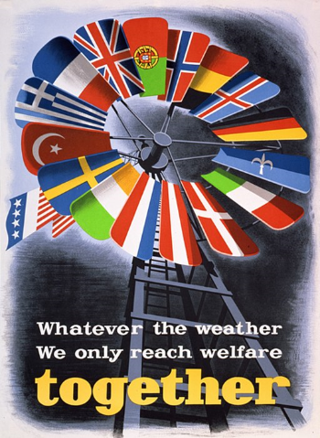

***Your eye is first drawn to the European flags in the windmill followed by the word TOGETHER. The message tells us that these countries are together.***